Dalson — Before vs After MAIA and E2E Flow

Dalson Industrial Supplies — Before vs After MAIA & E2E Flow
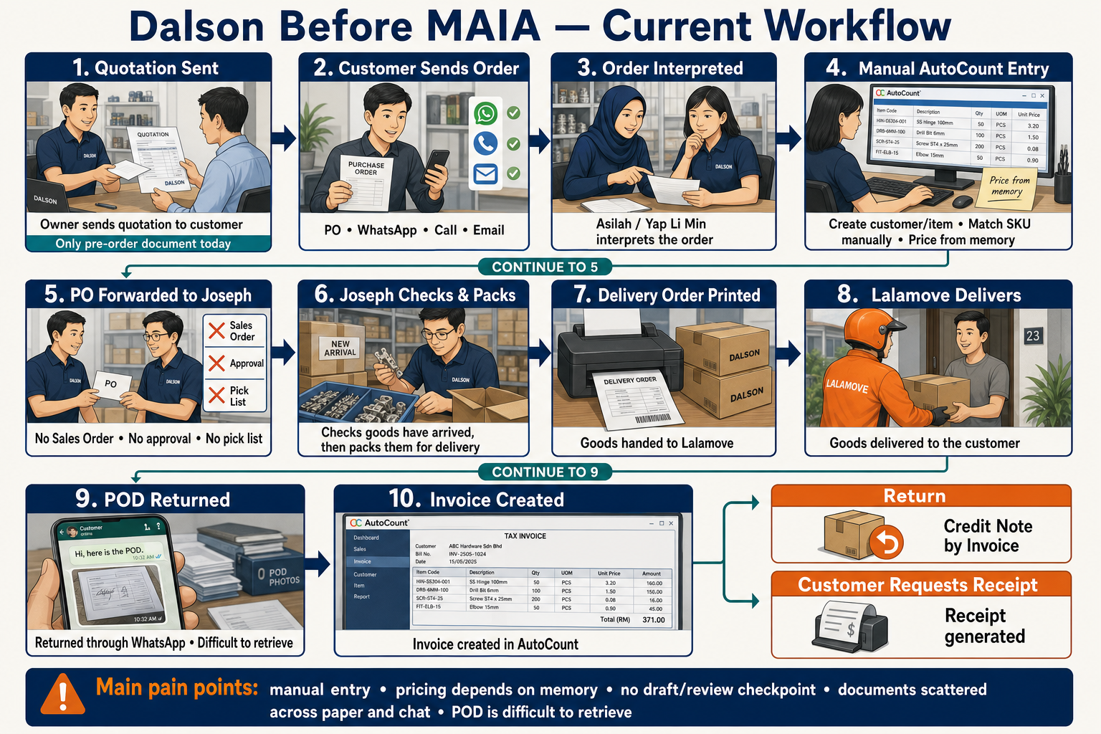

Before MAIA — Current (As-Is) Flow
text
┌───────────────────────────┐
│ Owner sends quotation │
│ to customer │
│ (only pre-order doc today)│
└─────────────┬─────────────┘
▼
┌───────────────────────────┐
│ Customer sends an order │
│ PO / WhatsApp / Call │
│ / Email │
└─────────────┬─────────────┘
▼
┌───────────────────────────┐
│ Asilah / Yap Li Min │
│ interprets the order │
└─────────────┬─────────────┘
▼
┌───────────────────────────┐
│ Manual AutoCount entry │
│ │
│ • Create customer/item │
│ • Match SKU manually │
│ • Price from memory │
└─────────────┬─────────────┘
▼
┌───────────────────────────┐
│ PO forwarded to Joseph │
│ │
│ • No Sales Order │
│ • No approval │
│ • No pick list │
└─────────────┬─────────────┘
▼
┌───────────────────────────┐
│ Joseph checks that the │
│ goods have arrived │
│ │
│ Joseph then packs the │
│ goods for delivery │
└─────────────┬─────────────┘
▼
┌───────────────────────────┐
│ Delivery Order printed │
│ │
│ Goods handed to Lalamove │
└─────────────┬─────────────┘
▼
┌───────────────────────────┐
│ Lalamove delivers the │
│ goods to the customer │
└─────────────┬─────────────┘
▼
┌───────────────────────────┐
│ POD returned through │
│ WhatsApp │
│ │
│ Difficult to retrieve │
└─────────────┬─────────────┘
▼
┌───────────────────────────┐
│ Invoice created in │
│ AutoCount │
└─────────────┬─────────────┘
▼
┌──────┴──────┐
▼ ▼
┌────────────┐ ┌────────────┐
│ Return │ │ Customer │
│ │ │ requests │
│ Credit Note│ │ receipt │
│ by Invoice │ │ │
└────────────┘ └────────────┘
- Owner sends a quotation before the customer's PO comes in — the only pre-order document that exists today. No formal Sales Order stage exists.
- Customer sends order — PO, text, or call to Dalson.
- Staff uploads the PO into AutoCount.
- Asilah (Sales Coordinator, desk-based) or Yap Li Min herself handles this — sources don't state a fixed split.
- No pick-list step — the PO is uploaded, that's the only structuring that happens before packing.
- PO is forwarded to Joseph (Store Keeper), who packs it directly.
- No intermediate pick-list or consolidation step — one PO in, one pack job out.
- Delivery happens via Lalamove (external courier); proof of delivery is exchanged informally over WhatsApp.
- Owner does not manage or organise this today — it just lives in chat threads.
- Delivery Order is printed.
- Retrieving a past DO later means manually searching a WhatsApp thread — described as genuinely hard to find again.
- Invoice is created in AutoCount — standard fields only, nothing unusual.
- Credit note, if needed, is issued against the specific invoice ID — never at the customer-account level. This is existing practice, not a before/after change.
- Receipt is only generated if the customer explicitly asks — not standard practice. Also unchanged by MAIA.
- New customer or new item, when it comes up: owner or coordinator manually keys it into AutoCount. Happens daily, not occasionally.
- Pricing is negotiated ad hoc, per customer — no fixed price list in AutoCount, just a single standard price per item; staff sets the real price case by case from memory.

Problems this creates
- Operational memory lives in scattered WhatsApp threads and paper. POs, DOs, and delivery proof aren't retrievable later without staff remembering where they put things.
- New-customer and new-item onboarding is a daily manual bottleneck. Every new customer or SKU means someone hand-keys it into AutoCount before anything else can move.
- No sales-order stage means no draft/review checkpoint before an order becomes a real document — whatever's uploaded goes straight to packing.
- SKU/item-description matching is informal. Customers describe items in their own words; matching to the right AutoCount SKU depends on staff judgement, no structured check exists.
- Pricing lives in staff's memory, not the system. Nothing shows what a customer paid last time, so pricing consistency depends entirely on whoever's handling the order remembering correctly.
- Cost model was opaque before go-live discussions — since resolved, but reflects how little visibility the owner had into system-driven costs before MAIA.

After MAIA — E2E Flow: Order Intake → Invoice
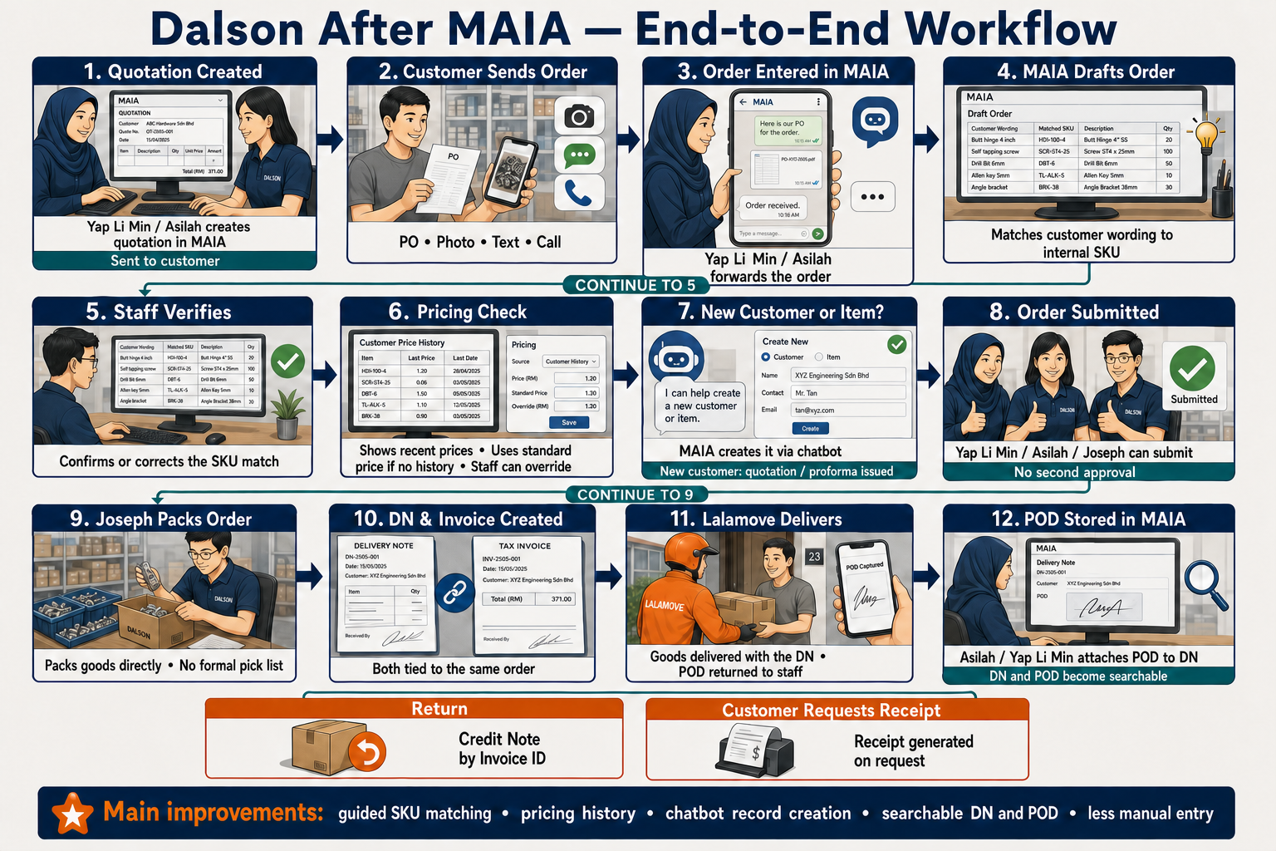
XML
STAFF: Yap Li Min / Asilah
|
| Creates QUOTATION in MAIA, sends to customer
v
CUSTOMER
|
| Sends PO / order request (photo, text, or call)
v
STAFF: Yap Li Min / Asilah
|
| Forwards order into MAIA via Telegram
v
MAIA
|
| Drafts the order, matches item wording to internal SKU
v
STAFF: CONFIRMS OR CORRECTS THE SKU MATCH
|
v
PRICING CHECK
- Customer has price history -> MAIA shows last few order
prices for that item, staff decides/confirms
- No history (new customer/item) -> MAIA defaults to the
standard AutoCount price, staff can override
|
v
NEW CUSTOMER OR NEW ITEM?
|
+--------+--------+
| |
Yes No
| |
MAIA creates directly |
via chatbot |
+ issues Quotation/ |
Proforma doc for new |
customer |
| |
+--------+--------+
|
v
SUBMISSION — no separate approval gate
Any of 3 registered users: Yap Li Min / Asilah / Joseph
|
v
JOSEPH: PACKS ORDER DIRECTLY
- No formal Pick List step (matches current practice)
- No stock-count update required for most SKUs — only the
small retail-facing slice is tracked
|
v
DN & INVOICE CREATED
|
v
GOODS HANDED TO LALAMOVE (external courier) WITH DN
|
v
LALAMOVE: DELIVERS, HANDS POD BACK (not a MAIA user)
|
v
ASILAH (or Yap Li Min): UPLOADS POD, ATTACHES TO THE DN IN MAIA
|
+--------+--------+
| |
Return occurs Customer requests receipt
| |
v v
CREDIT NOTE ISSUED RECEIPT GENERATED
(invoice-level only) (on request only)

1. Order Intake
- Where relevant, Dalson sends a quotation to the customer first — the only pre-order document in their flow. Created in MAIA and stays in MAIA only (SL-13, MED confidence) — per written client confirmation (Sample Data Checklist doc) and a direct client quote (WhatsApp, 2026-05-26: "if MAIA can do her own 'quotation' with her own SKU is ok de"). A 2026-07-31 edit to this doc had claimed the quotation is pushed to AutoCount, citing an unattributed "direct check" — that claim was rejected in the Scope Lock v2 reconciliation pass (Supersessions Log S8) for lacking a citation, and this doc has been corrected to match. Still needs a properly attributed live-system re-verification before this is treated as fully settled — see Scope Lock Client Confirmation Agenda.
- Customer sends a PO — photo, text, or call — to Dalson.
- Staff (Asilah or Yap Li Min) forwards it into MAIA via Telegram.
- MAIA drafts the order and matches the item wording to Dalson'"'"'s internal SKU.
- Staff confirms the SKU match, or corrects it if it looks off — nothing gets committed on a guess.
- MAIA checks pricing:
- If the customer has ordered that item before, MAIA shows the last few order prices so staff can decide/confirm the price.
- If there's no price history (new customer or first order on that item), MAIA defaults to the standard AutoCount price; staff can still override it.
- No formal Sales Order stage — the quotation/SO-equivalent stays in MAIA only; only Invoice and DO push to AutoCount.
- New customer or new item: MAIA creates it directly through the chatbot — no manual AutoCount entry needed. For a new customer, MAIA also issues a quotation/proforma document to collect payment upfront (also stays in MAIA only).

2. Submission — No Separate Approval Gate
- Any of the 3 registered users — Yap Li Min, Asilah, or Joseph — submits the draft directly.
- No second sign-off required; client confirmed this is safe for a 3-person team.
- Submitted order is pushed to AutoCount, which stays the system of record.

3. Fulfillment
- Joseph (Store Keeper) receives the submitted order and packs it directly.
- No formal pick-list step — matches how Dalson already works.
- No stock-count update required for most SKUs — Dalson trades heavily, stock turns straight back out; only the small retail-facing slice is actually tracked.

4. DN & Invoice Creation
- Once packing is done, the DN and Invoice are created, tied to the same order.

5. Delivery & Proof of Delivery
- Goods go out with the DN via Lalamove (external courier) — not a MAIA user.
- Lalamove delivers and hands the POD (photo/signed doc) back to staff afterward.
- Asilah (or Yap Li Min) uploads the POD and attaches it to the DN in MAIA.
- This closes the old "master DO" retrieval pain — DOs with their attached POD are searchable in MAIA instead of buried in a WhatsApp thread.

6. Credit Note (if applicable)
- If a return occurs, the credit note is issued against the specific invoice ID — never at the customer-account level.

7. Receipt (if requested)
- Receipt is generated only if the customer asks — never automatically.

Per-Role: What Each User Does

Yap Li Min — Owner / Sales Coordinator (dual role)

Responsibilities
- Submits draft SO/Invoice directly — no separate approval step.
- Sets business rules: credit note policy (invoice-level only), receipt policy (on-request only).
- Field/mobile-based; uses MAIA remotely.

Benefits
- No longer personally carries every document handoff in her head.
- Can review order history, credit terms, and pricing history without digging through AutoCount manually.

Risks
- UAT signatory role still open — unclear if she's the sole UAT signatory or if Asilah/Joseph sign off their own portions.

Asilah Amirah binti Khairuddin — Admin/ Sales Coordinator

Responsibilities
- Forwards customer POs into MAIA via Telegram.
- Submits SO/Invoice directly — previously blocked, now no gate exists.
- Creates new customer/item records via chatbot.
- Receives POD from Lalamove after delivery, uploads it, and attaches it to the DN in MAIA — Lalamove is not a MAIA user.

Permissions
- Visibility scope still open — whether she sees only her own assigned customers/orders or all of Dalson's orders is unconfirmed anywhere in sources (Gap #5, End-user & Process Map).

Benefits
- New-customer/item creation no longer requires a separate manual AutoCount pass — directly closes a daily bottleneck.

Risks
- Role description in sources is still owner-reported (BELIEVED), not her own voice — worth confirming directly at UAT sign-off.

Joseph — Store Keeper / Admin

Responsibilities
- Receives confirmed orders, packs directly.
- Same direct submission rights as Yap Li Min and Asilah — not his normal day-to-day, but available if it falls to him.

Benefits
- Order routing through MAIA instead of a forwarded WhatsApp message — same simple hand-off, less ambiguity about what to pack.

Risks
- No formal pick-list step is introduced by MAIA — the workflow simplicity is preserved, but so is the lack of a structured picking check.

Lalamove — External Courier (not a MAIA user)

Responsibilities
- Delivers the goods.
- Hands the POD (photo/signed doc) back to staff after delivery.

Not a MAIA user
- Lalamove has no MAIA login or in-app role. POD capture and filing is staff's step (Asilah, or Yap Li Min) — see her role above.

Ms Tan — AutoCount Software Support (external, not a MAIA end-user)

Responsibilities
- Manages Dalson's AutoCount instance; coordinated data migration and integration access.
- Technical point of contact for any AutoCount-side sync questions.

Not a MAIA user
- No MAIA login, view, or submission rights — AutoCount-side only.

Open Gaps Carried Into This Doc
- UAT signatory — sole (Yap Li Min) vs. multi-signatory (Asilah/Joseph each on their portion). (open)
- Asilah's visibility scope — own customers only vs. all of Dalson's orders. (open)

See Also
- [[Dalson — VoC Extraction]]
- [[Dalson — End-user & Process Map]]
- [[Dalson — UAT Checklist]]
- [[Dalson — Lens Alignment Report]]
- Scope Lock v2 — Dalson Industrial Supplies (Lark, doc token VHQPdEnCbopM9pxRapJliGiXgrb)

